DIGITAL SYSTEM DESIGN
1# Differentiate between weighted and non-weighted binary codes. give example of each.
Weighted codes | Non-weighted codes
- Each position in the code has a specific weight | - Position of code no not have a specific weight
- Decimal value of code can be determined | - Decimal value assigned to each code.
- Example of these codes is: BCD, 8421, 6421, 4221, 5211, 3321 etc. | - Examples of non-weighted codes are: Un-weighted BCD code, Excess-3 code and gray code.

example of each:
BCD:  8421 Code  94→ 9 4  ↓ ↓  Code→ 8+4+2+1 8+4+2+1  1+0+0+1 0+1+0+0  =1001 0100 | (48)10 into Excess−3 code  48→ 4 8  +3 +3  Excess-3: 7 11  Code ↓ ↓  0111 1011

2# Design a code converter to concert a 4-bit binary number 1101 to it’s corresponding gray code. Provide the truth table and circuit
diagram.
Converting a binary number to its corresponding Gray code involves a specific algorithm where each bit of the Gray code is calculated based on the corresponding bits of the binary number. Let's first create a truth table for the conversion:
Binary (B3 B2 B1 B0) | Gray (G3 G2 G1 G0)
1 1 0 1 | 1011
Truth table for XOR gate:
B | XOR | Output
0 | 0 | 0
0 | 1 | 1
1 | 0 | 1
1 | 1 | 0
Using this truth table, you can create the XOR gates for each bit conversion as shown in the circuit diagram.
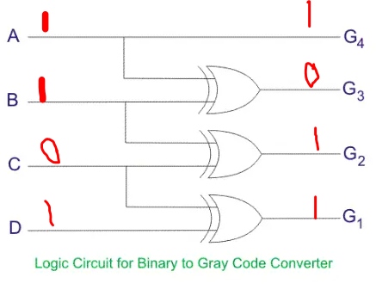
The binary to gray code converter circuit is shown below:

In this circuit:
- B3, B2, B1, B0 are the input binary bits.
- G3, G2, G1, G0 are the output Gray code bits.
- Each pair of binary bits (B3-B2, B2-B1, B1-B0) is connected to a separate XOR gate.
- The output of each XOR gate is a corresponding Gray code bit (G3, G2, G1, G0).

3# Write the advantages of gray code over the straight binary number sequence.

Gray code, also known as reflected binary code, offers several advantages over the straight binary number sequence:
- The advantage of the Gray code over straight binary number sequence is that only one bit in the code group changes in going from one number to the next.
- Gray code ensures that only one-bit changes between consecutive values, reducing the chances of errors due to bit transitions, crucial in applications sensitive to errors, like digital communication and rotary encoders.
- Gray code is widely used in binary counters and digital control systems, as it prevents false triggering and ensures consistent counting sequence.
- Gray code prevents glitches that can arise when changing straight binary numbers due to varying propagation delays in digital systems, ensuring accurate and glitch-free transitions.
4# Why NAND gate and NOR gate are called universal gate? Explain it with proper diagram.
In Boolean Algebra, the NAND and NOR gates are called universal gates because any digital circuit can be implemented by using any one of these two i.e. any logic gate can be created using NAND or NOR gates only.
Although and,or and not are basic gates but each of their functionality can be derived using nand and not as well.One more important aspect because of this AOI logic can be converted to either Nand or Nor logic.
The following is the implementation of all the gates using NAND:-
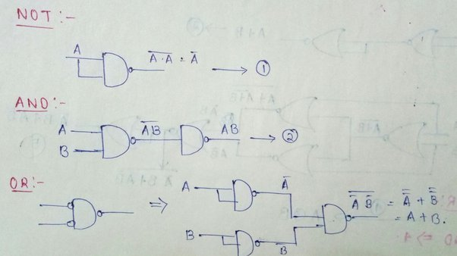
Now the following is the implementation of all the gates using NOR:-
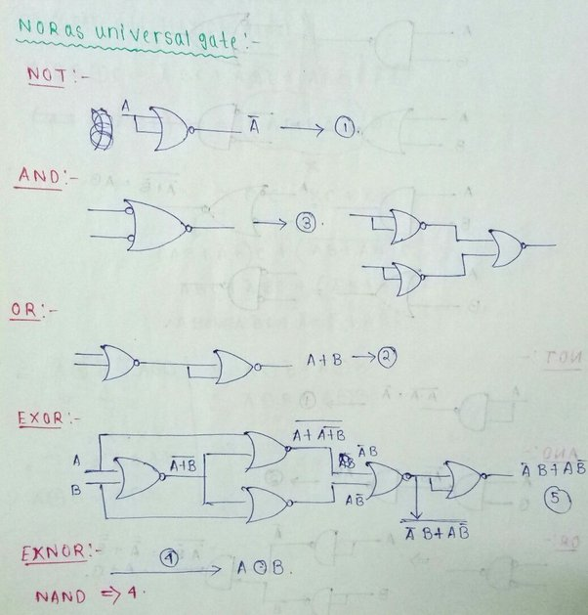
This demonstrates how a combination of NAND gates can be used to implement different logic gates. This universality property is the reason why NAND and NOR gates are called universal gates in digital logic design.

5# Construct a 3-to-8 decoder using NAND gates.
The figure below shows the truth table of 3-to-8 line decoder using NAND gates. Each output in the table gives a max term representation.
At a given time only one output is low and all other outputs will be high. For example, when A=B= 1 and C=0, then the output Y6 is zero and all other outputs are high as shown in below figure.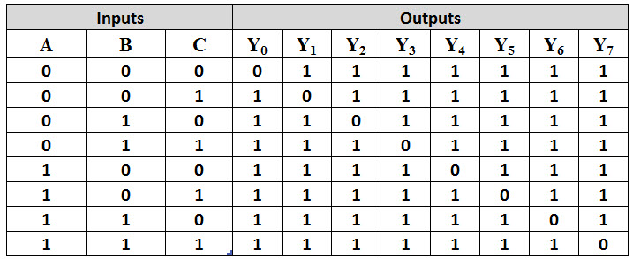
From the above table , a 3-to-8 line decoder is designed by using three NAND gates and three NOT gates. NOT gates generate the complement of input while the NAND gates generate max terms of each output as shown in below figure.
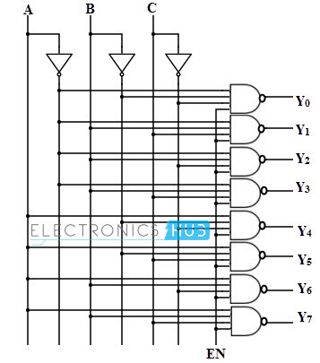

6# How parity bit can be used for single-bit error detection? Explain with an example.
Parity Bit Method : A parity bit is an extra bit included in binary message to make total number of 1’s either odd or even. Parity word denotes number of 1’s in a binary string. There are two parity system – even and odd parity checks.
There are two common types of parity: even parity and odd parity.
Even Parity: The total number of set (1) bits, including the parity bit, should be even.
Odd Parity: The total number of set (1) bits, including the parity bit, should be odd.
Example: A parity bit, added to data, counts set bits for even or odd parity. Example: Data 1011 with even parity becomes 10110. If received data's parity doesn't match set bit count, a single-bit error is detected, e.g., 11110 indicates error.

7# What is a full adder circuit. Why it is used? Construct a full adder circuit using two half adder.
A full adder circuit is a digital logic circuit that performs the arithmetic operation of adding three binary digits together. It takes three inputs: A, B, and Cin (carry-in), and produces two outputs: Sum (S) and Cout (carry-out). The full adder is used in digital circuits like CPUs to add binary numbers...
A full adder circuit is a digital logic component that adds three binary inputs (A, B, Cin) to produce a sum output (S) and a carry output (Cout). It's essential for arithmetic operations in CPUs and other digital systems…
The logic diagram of the full adder using two half adders is shown in Figure-3:
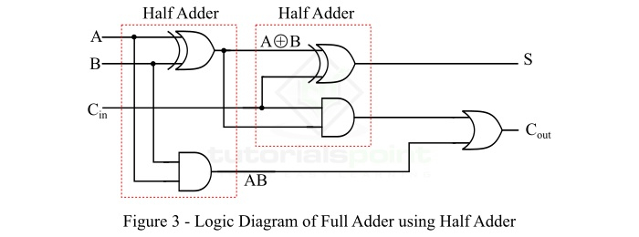

8# Implement the function Y=AB+CD using a 4-to-1 multiplexer. Show the truth table and circuit.
Step 1:
Make a truth table:
A | B | C | D | Y=AB+CD
0 | 0 | 0 | 0 | 0
0 | 0 | 0 | 1 | 0
0 | 0 | 1 | 0 | 0
0 | 0 | 1 | 1 | 1
0 | 1 | 0 | 0 | 0
0 | 1 | 0 | 1 | 0
0 | 1 | 1 | 0 | 0
0 | 1 | 1 | 1 | 1
1 | 0 | 0 | 0 | 0
1 | 0 | 0 | 1 | 0
1 | 0 | 1 | 0 | 0
1 | 0 | 1 | 1 | 1
1 | 1 | 0 | 0 | 1
1 | 1 | 0 | 1 | 1
1 | 1 | 1 | 0 | 1
1 | 1 | 1 | 1 | 1

Figure 0: truth table
Step 2: implemented using 4:1 mux in following way.. This is an 4X1 MUX with inputs I0,I1,I2,I3 , Y as output and S1, S0 as selection lines. The output will depend upon the combination of S1 & S0 as shown in the truth table figure 2.
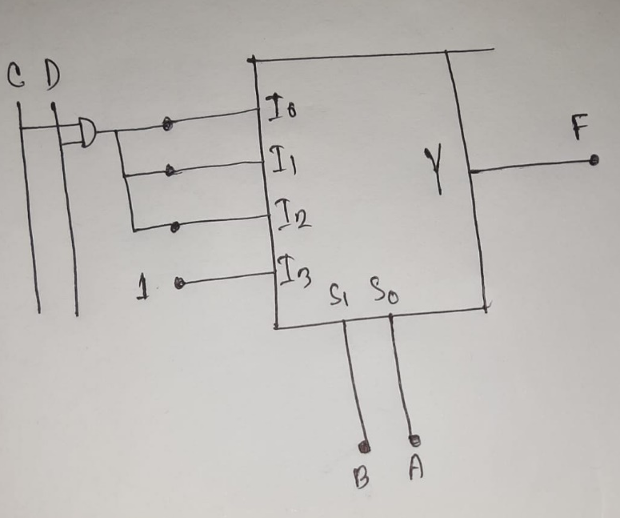
Figure-1:$4×1$ MUX.
Step 3: $S_{0}=A;$
$S_{1}=B;$
Step 4: create a truth table for selection lines.
$$S_{1}$$ | $$S_{0}$$ | Y
0 | 0 | $$I_{0}=CD$$
0 | 1 | $$I_{1}=CD$$
1 | 0 | $$I_{2}=CD$$
1 | 1 | $$I_{3}=1$$
Figure 2: truth table
The 4-to-1 multiplexer can be used to implement the logic function Y = AB + CD. By selecting the appropriate inputs based on the truth table, the multiplexer produces the correct output value according to the given formula. This illustrates how multiplexers can be used to perform logic operations and implement complex functions using a combination of input signals and control bits.

9# Simplify this Boolean expression using Boolean logic, (A+B’+C’)(A+B’+C)(A+B+C’)
Solution:
Given Boolean expression: (A + B’ + C’)(A + B’ + C)(A + B + C’)
Now, using the distributive law, we can write
= [(A+B’) + C’C](A + B + C’)
Using AA’ = 0, it becomes
[(A+B’) + 0](A + B + C’)
Since A + 0 = A,
= (A+B’)(A + B + C’)
= A + B’.(B+C’)
Again, using distributive law
= A + B’B +B’C’
= A + 0 + B’C’
= A + B’C’.

10# What is the difference between encoder and multiplexer? Construct a full adder circuit with a 3-to-8 decoder.
Encoder | Multiplexer
The encoder is a combinational circuit element that encodes a set of binary codes into another set of binary codes containing a smaller number of bits. | The multiplexer is a combinational circuit element that channels one of its many inputs to its only output depending on the selection inputs.
An encoder has n number of outputs if it has 2^{n} number of input pins. | A multiplexer has only one output pin irrespective of the number of input pins.
If an encoder has 2^{n} number of input pins then it will have n number of output pins. | A multiplexer has multiple numbers of input pins and the number of input pins is given by 2^{n} and it has only 1 output.
The encoder does not have any selection input lines. | If a multiplexer has 2^{n} number of input pins then it will have n number of selection lines.
The encoder is used to encode a particular set of binary sequences into another set binary sequence of a smaller number of bits. | The multiplexer is used to multiplex one of its input signals into its output depending on the selection input.
8-bit code to BCD, 16-bit code to 4-bit binary code, etc. are the examples of applications of the encoder. | Parallel to serial converter, digital switch, signal multiplexing, etc. are the examples of applications of the multiplexer.
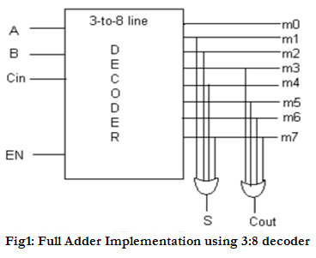
11# Define multiplexer and explain it’s mole in digital systems. Implement F(A,B,C,D)=$\sum{(1,2,4,8,9,15)}$ with an 8$×$1 MUX.
Part 1:
A multiplexer is a combinational circuit that has 2n input lines and a single output line. Simply, the multiplexer is a multi-input and single-output combinational circuit. The binary information is received from the input lines and directed to the output line. On the basis of the values of the selection lines, one of these data inputs will be connected to the output.
Unlike encoder and decoder, there are n selection lines and 2n input lines. So, there is a total of 2N possible combinations of inputs. A multiplexer is also treated as Mux.

Part 2:
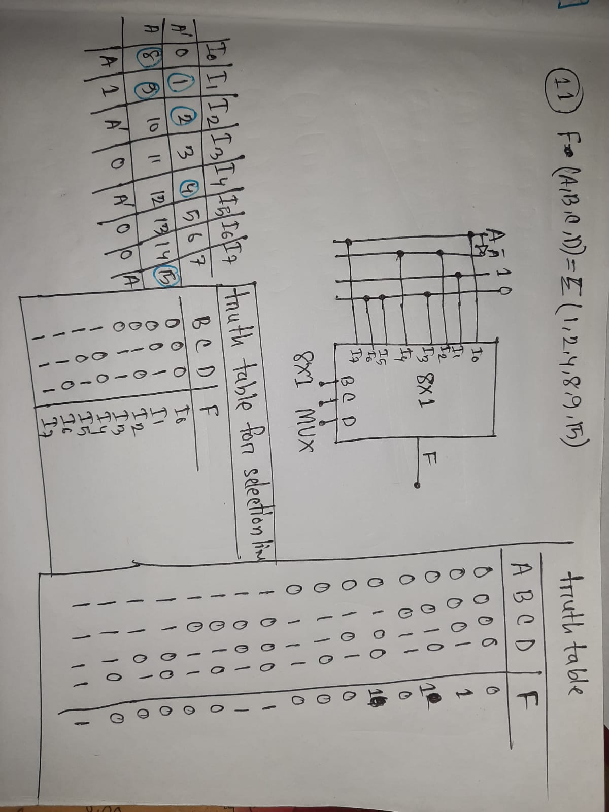

12# Defne shift registers, ripple counter, discuss their application in digital systems.
Shift Register is a group of flip flops used to store multiple bits of data. The bits stored in such registers can be made to move within the registers and in/out of the registers by applying clock pulses. An n-bit shift register can be formed by connecting n flip-flops where each flip-flop stores a single bit of data.
Applications of Shift Registers
- The shift registers are used for temporary data storage.
- The shift registers are also used for data transfer and data manipulation.
- The serial-in serial-out and parallel-in parallel-out shift registers are used to produce time delay to digital circuits.
Ripple counter is a cascaded arrangement of flip-flops where the output of one flip-flop drives the clock input of the following flip-flop.
Applications of ripple Counters
- They are used as frequency dividers, as divide by “N” counters.
- They are used for low noise emission and low power applications
- They are used in designing asynchronous decade counter.
- It is also used in Ring counter and Johnson counter.
- Asynchronous counters are used in Mod N ripple counters. i.e. Mod 3, Mod 4, Mod 8, Mod 14, Mod 10 etc.

13# What are the advantages of synchronous counter over asynchronous counter? Illustrate with examples.
1.Synchronas counters are easy to design since same clock pulse is required for all flip-flops.
2. Synchronas counters have same time delay throughout the circuit, thus by knowing the time delay of any flip-flop, we can predict the timing of output but in case of Assyncronous counters time delay gets increased at each level of flip-flop
3. Synchronas counters are fast while Assyncronous counters are slow.
Example 1:4-Bit Binary Up Counter
  - Consistent Timing: All bits change together on clock cycles.
  - Reduced Glitches: Synchronous operation minimizes glitches.
  - Predictable Outputs: Binary counting sequence is maintained.
Example 2: Cascade of Counters
  - Easier Cascading: Simple distribution of a single clock.
  - Consistent Timing: Synchronized update for accurate counting.

14# Design a MOD-7 synchronous up counter with proper diagram.
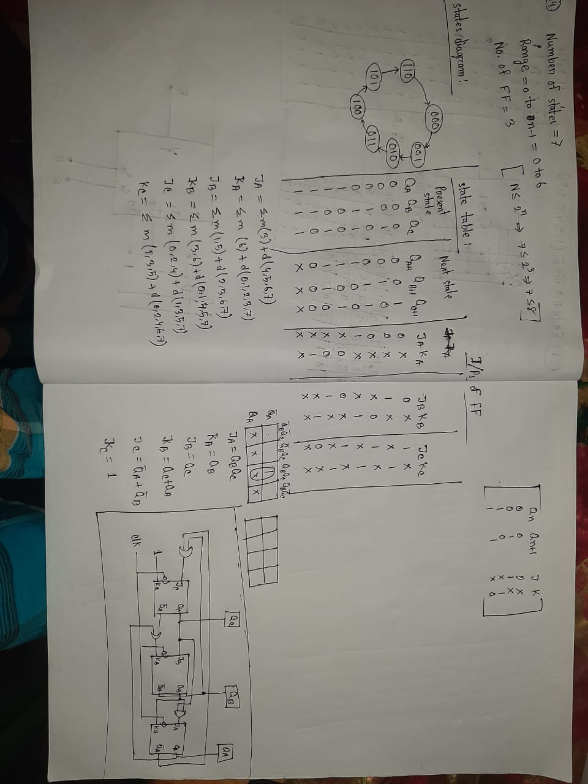
15# Write the difference between combinational and sequential circuits.
Combinational circuits are defined as the time independent circuits which do not depends upon previous inputs to generate any output are termed as combinational circuits. Sequential circuits are those which are dependent on clock cycles and depends on present as well as past inputs to generate any output. Combinational Circuit –
- In this output depends only upon present input.
- Speed is fast.
- It is designed easy.
- There is no feedback between input and output.
- This is time independent.
- Elementary building blocks: Logic gates
- Used for arithmetic as well as boolean operations.
- Combinational circuits don’t have capability to store any state.
- As combinational circuits don’t have clock, they don’t require triggering.
- These circuits do not have any memory element.
- It is easy to use and handle.
Examples – Encoder, Decoder, Multiplexer, Demultiplexer Block Diagram –
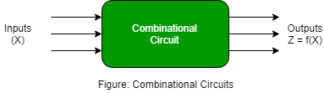
Sequential Circuit –
- In this output depends upon present as well as past input.
- Speed is slow.
- It is designed tough as compared to combinational circuits.
- There exists a feedback path between input and output.
- This is time dependent.
- Elementary building blocks: Flip-flops
- Mainly used for storing data.
- Sequential circuits have capability to store any state or to retain earlier state.
- As sequential circuits are clock dependent they need triggering.
- These circuits have memory element.
- It is not easy to use and handle.
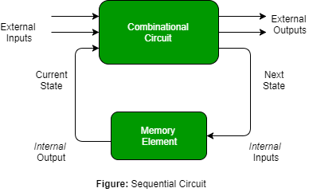

16# Design a D-type flip-flop using NAND gates. Provide the truth table and circuit diagram.
A D-type flip-flop can be designed using NAND gates. Here is the truth table for a D-type flip-flop:

Clk | D | Q | Q | Description
↓ » 0 | X | Q | Q | Memory  no change
↑ » 1 | 0 | 0 | 1 | Reset Q » 0
↑ » 1 | 1 | 1 | 0 | Set Q » 1

Here is the circuit diagram for a D-type flip-flop using NAND gates:
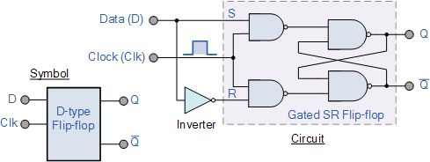\
We remember that a simple SR flip-flop requires two inputs, one to “SET” the output and one to “RESET” the output. By connecting an inverter (NOT gate) to the SR flip-flop we can “SET” and “RESET” the flip-flop using just one input as now the two input signals are complements of each other. This complement avoids the ambiguity inherent in the SR latch when both inputs are LOW, since that state is no longer possible.

17# Convert a JK flip-flop into D flip-flop. Explain with circuit diagram.
A JK flip-flop can be converted into a D flip-flop by using the following steps:
- Step-1:
We construct the characteristic table of D flip-flop and excitation table of JK flip-flop.
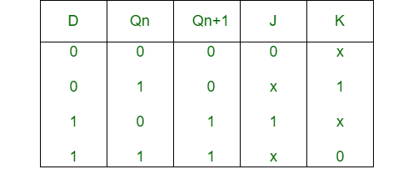
- Step-2:
Using the K-map we find the boolean expression of J and K in terms of D.
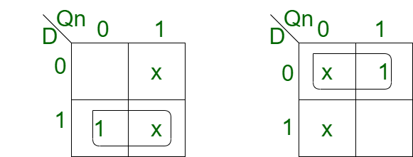
J = D
K = D'
- Step-3:
We construct the circuit diagram of the conversion of JK flip-flop into D flip-flop.
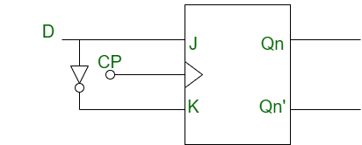

18# Discuss the advantages and applications of field programmable gate arrays (FPGAS) in digital design and its architecture. (PAL)
and programmable logic array (PLA).
Field Programmable Gate Arrays (FPGAs) are integrated circuits that consist of internal hardware blocks with user-programmable interconnects to customize operation for a specific application. The interconnects can readily be reprogrammed, allowing an FPGA to accommodate changes to a design or even support a new application during the lifetime of the part.
FPGAs have several advantages over other digital design technologies. They are highly flexible and can be programmed to perform any digital function. They are also highly parallel and can perform multiple operations simultaneously.
Programmable Array Logic (PAL) and Programmable Logic Array (PLA) are two types of programmable logic devices that were used before FPGAs became popular. PALs are programmable logic devices that have a fixed OR array and a programmable AND array. PLAs are programmable logic devices that have both programmable AND and OR arrays.
19# Explain the purpose and functioning of programmable array logic.
Programmable Logic Array(PLA) is a fixed architecture logic device with programmable AND gates followed by programmable OR gates. PLA is basically a type of programmable logic device used to build a reconfigurable digital circuit. A PLA is a fixed architecture logic device with programmable AND gates followed by programmable OR gates. It is used to build a reconfigurable digital circuit.A programmable logic array (PLA) is a type of logic device that can be programmed to implement various kinds of combinational logic circuits.
A programmable logic array is designed such that a number of different logical functions can be combined as a sum-of-product or product-of-sum form. A PLA having N input buffers and M output buffers consists of 2N AND gates and M OR gates, each with programmable inputs from all of the AND gates. PLAs have widely been acknowledged as compact and space-efficient solutions for many complicated circuits, especially in feedback and control systems where a number of factor variables must be involved for efficient functioning of the system.
20# Implement the Boolean function using PAL.
$Y_{1}=\sum{m}\left(2,3,5,7\right)$
$Y_{2}=\sum{m(3,6)}$
Implement the given function by using PAL:
Following Truth table will be helpful in understanding function on number of inputs:
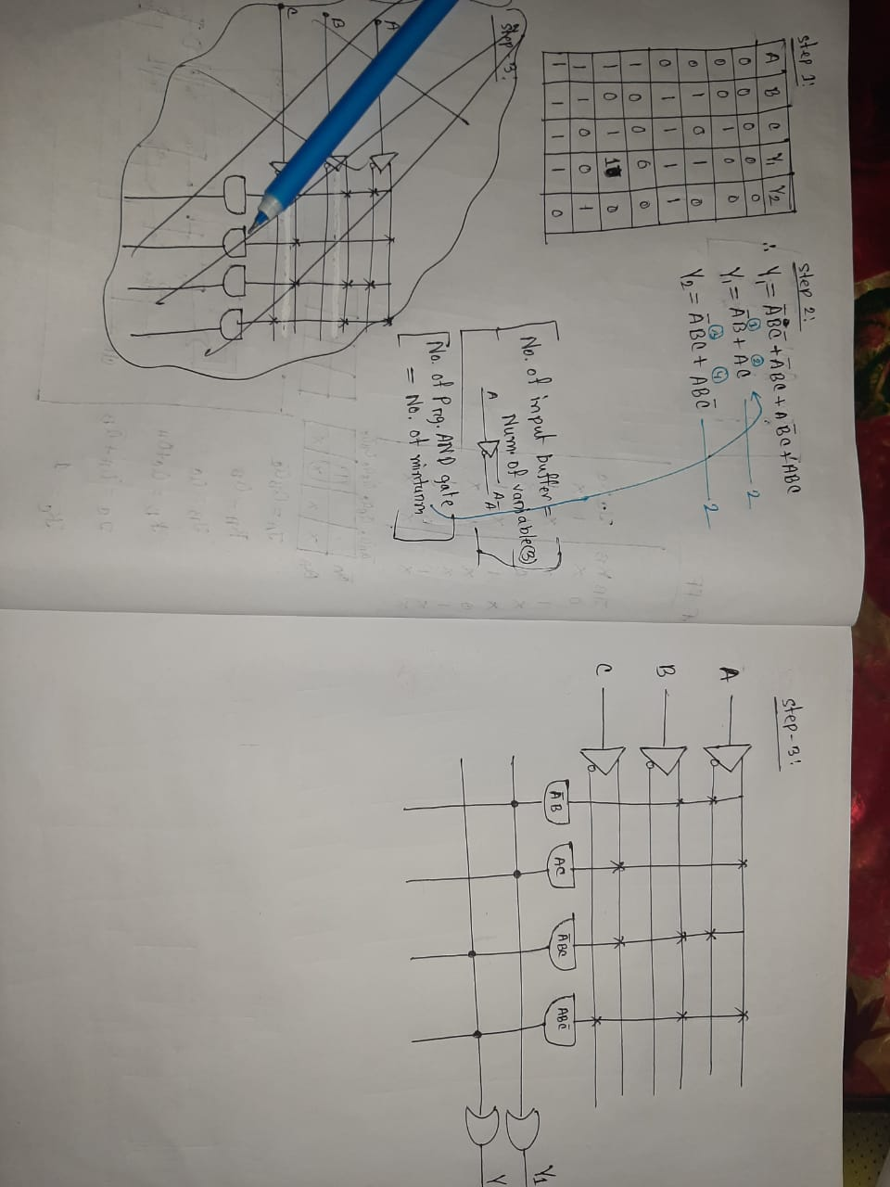

21# What is hardware description language? What are the requirements of a good HDL? Describe the abstraction level of Verilog HDL.
22 # Drow the HDL design flow.
23 # Write a VHDL code to implement a 4-bit full adder.

